

Chemistry ATAR 1+2

Properties and Structure of Atoms Test

Name : ________________________________ Teacher: ___________________________

TIME ALLOWED: 55 MINUTES (55 marks total)

Part A: Multiple Choice Questions. (10 marks)

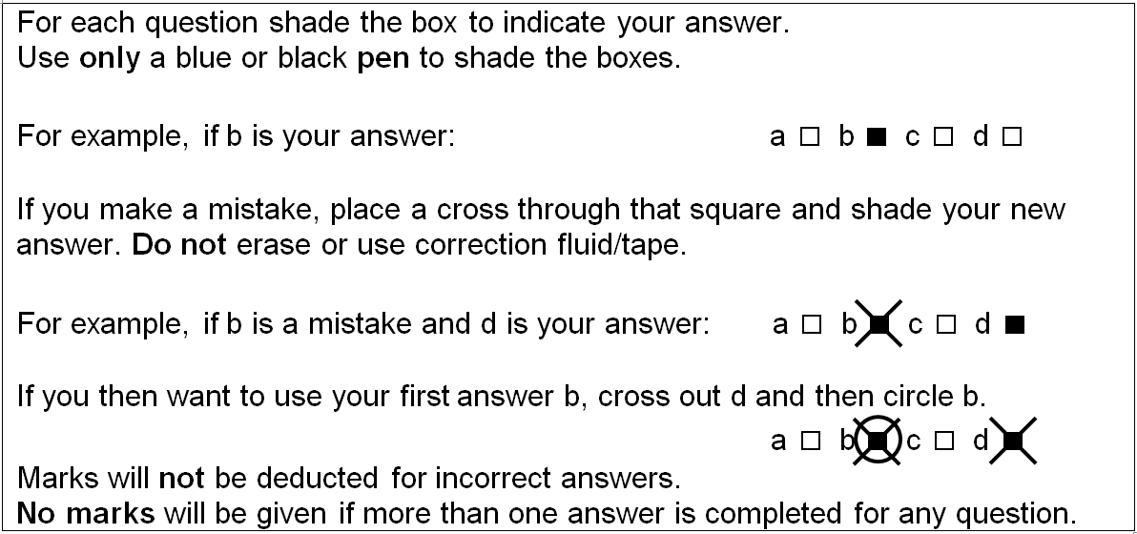

1 | a □ b □ c □ d □ |  | 6 | a □ b □ c □ d □
2 | a □ b □ c □ d □ |  | 7 | a □ b □ c □ d □
3 | a □ b □ c □ d □ |  | 8 | a □ b □ c □ d □
4 | a □ b □ c □ d □ |  | 9 | a □ b □ c □ d □
5 | a □ b □ c □ d □ |  | 10 | a □ b □ c □ d □

Chemistry ATAR 1+2

Properties and Structure of Atoms Test

Name : ________________________________ Teacher: ___________________________
A  Multiple Choice Section | B  Short Answer Section | Total
/10 | /46 | /56

TIME ALLOWED: 55 MINUTES (56 marks total)

Q1. The species 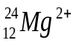 contains

A. 12 protons, 12 neutrons and 12 electrons
B. 12 protons, 12 neutrons and 14 electrons
C. 12 protons, 10 neutrons and 10 electrons
D. 12 protons, 12 neutrons and 10 electrons

Q2. Some information about the element rhenium (Re) is given in the table below.
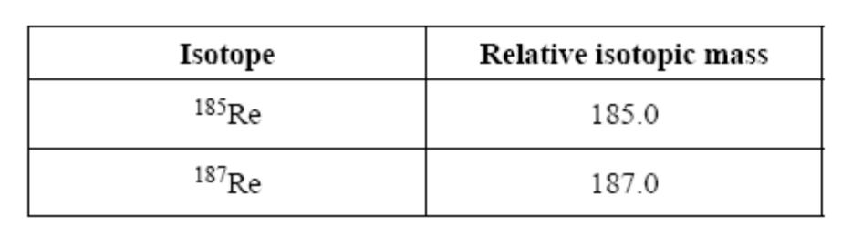
Given that the relative atomic mass of Re is 186.2, the percentage abundance of ¹⁸⁵Re is closest to

A. 40
B. 50
C. 60
D. 70

Q3. A set of isoelectronic (same electron configuration) ions is:

A. S²⁻, K⁺, Ne, Cl⁻

B. O²⁻, S²⁻, Se²⁻, Te²⁻

C. S²⁻, Ca²⁺, K⁺, Cl⁻

D. Al³⁺, P³⁻, S²⁻, Cl⁻.

Q4. In two species, the first has 29 protons, 29 electrons and 36 neutrons, and the second has 29 protons, 28 electrons, and 36 neutrons.

The two species are:

A. an atom and a cation.

B. an atom and an anion.

C. allotropes of each other.

D. isotopes of each other.

Q5. An element X from group 1 period 3 is…

A. 2, 8, 1
B. 2, 7
C. 2, 5
D. 2, 8

Q6. Which of the following species will be deflected to the greatest extent in a mass spectrometer?

- ¹³⁷A
- ¹³⁵A⁺
- ¹³⁶A⁺
- ¹³⁵A²⁺

Q7. Which statement about Atomic Absorption Spectroscopy (AAS) is correct?

- AAS is an effective qualitative technique but it cannot be used for quantitative analysis
- AAS measures the wavelengths of light emitted when electrons fall back to their ground state
- In AAS, white light is shone through a vaporised sample in order to observe which wavelengths are absorbed
- The wavelength of light used in AAS matches one of the spectral lines produced when the sample is analysed by a flame test

Q8. What is the purpose of the flame in atomic absorption spectroscopy (AAS)?

- To ionise the sample
- To produce a spectrum
- To atomise the substance
- To provide the absorption wavelength

Q9. Which of the following is the reason an atom and its ion have almost the same mass?

- There is no significant difference between and atom and its ion.
- The nucleus of an atom is unaffected when an atom becomes an ion.
- Most atoms have isotopes.
- The mass of an electron is insignificant when compared to the mass of a proton or neutron.

Q10. A positively charged particle with the electron configuration 2, 8 could be:

- a neon atom.
- a sodium atom.
- a fluoride ion.
- a potassium ion.

END OF PART A

PART B: SHORT ANSWER QUESTIONS (45 marks)

Q11. Complete the following table:
(i) Name the species.
(ii) Draw electron configurations of the species.

SPECIES | NAME OF  SPECIES | Electron Config
Mg
N^{3–}
F–
Ne
(8 marks)

Q 12. An ancient mass spectrometer prints out some data in a list instead of a graphical representation. Draw a sketch of what would be observed in a graph showing this data. (3 marks)

m/z ratio | Detection
136⁺ | 80
135⁺ | 2010
134⁺ | 350
133⁺ | 210
132⁺ | 19

Q 13. Complete the following table (4 marks)

Symbol | Atomic Number | Mass Number | Number of protons | Number of Electrons | Number of Neutrons | Electron Configuration
 | 20 | 40 |  | 20
²⁴Na⁺ | 11 |  | 11

Q 14. a) A sample of Hydrogen exists as a mixture of three isotopes. (3 marks)

mass number 3, relative abundance 0.126 %
mass number 2, relative abundance 0.674 %
mass number 1, relative abundance 99.2 %
Calculate the relative atomic mass of hydrogen to 3 decimal places.

________________________________________________________________________________________

________________________________________________________________________________________

________________________________________________________________________________________

________________________________________________________________________________________

________________________________________________________________________________________

b) Define relative atomic mass (1 mark)

________________________________________________________________________________________

________________________________________________________________________________________

Q15. Potassium has a relative atomic mass of 39.113. The mass spectrometer reveals that there are two main isotopes of potassium: ³⁹K and ⁴⁰K.

(a) What is the percentage abundance of each element? (2 marks)

________________________________________________________________________________________

________________________________________________________________________________________

________________________________________________________________________________________

________________________________________________________________________________________

________________________________________________________________________________________
(b) Complete the table (i-vi) below showing the numbers of sub-atomic particles for an atom of ³⁹K and an ion ⁴⁰K⁺

 | ³⁹K | ⁴⁰K⁺
Number of electrons
Number of neutrons
Number of protons
(3 marks)
(c) In the Periodic Table Calcium is in the same period as Potassium.
Why do these elements belong to the same period? (1 mark)

________________________________________________________________________________________

________________________________________________________________________________________

________________________________________________________________________________________
(d) Compare and contrast two isotopes in terms of chemical and physical properties.
(4 marks)

________________________________________________________________________________________

________________________________________________________________________________________

________________________________________________________________________________________

________________________________________________________________________________________

________________________________________________________________________________________

________________________________________________________________________________________

Q16.
(a) Explain, in terms of electrons, with a diagram how a flame test works. (3 marks)

________________________________________________________________________________________

________________________________________________________________________________________

________________________________________________________________________________________

(b) Explain the difference between an emission spectra and absorption spectra. (4 marks)

________________________________________________________________________________________

________________________________________________________________________________________

________________________________________________________________________________________

________________________________________________________________________________________

________________________________________________________________________________________

________________________________________________________________________________________

Q17. (a) What is electronegativity? (1 mark)

________________________________________________________________________________________

________________________________________________________________________________________

(b) Explain what happens to electronegativity as you go across the Periodic Table, from left to right in the second period? (2 marks)

________________________________________________________________________________________

________________________________________________________________________________________

________________________________________________________________________________________

________________________________________________________________________________________

(c) Explain in terms of electrostatics, the trend in electonegativity that you stated in part (b).
(2 marks)

________________________________________________________________________________________

________________________________________________________________________________________

________________________________________________________________________________________

________________________________________________________________________________________

(d) Define ionisation energy, and explain the trend of the group 2 elements as you go down the group. (3 marks)

________________________________________________________________________________________

________________________________________________________________________________________

________________________________________________________________________________________

________________________________________________________________________________________
(e) Explain what happens to the atomic radius of the elements as you go across period 2.
(2 marks)

________________________________________________________________________________________

________________________________________________________________________________________

________________________________________________________________________________________

________________________________________________________________________________________

END OF TEST

